Kelompok 8

Nama : Mas Adam Khalidas Hakim (18081010117)

Erik Prasetiyo Nugroho (18081010118)

Iqbal Alfiansya (18081010123)

Mochammad Andika P M (18081010129)

Kevin Haniv Wicaksana (18081010130)

Tugas Final Projek

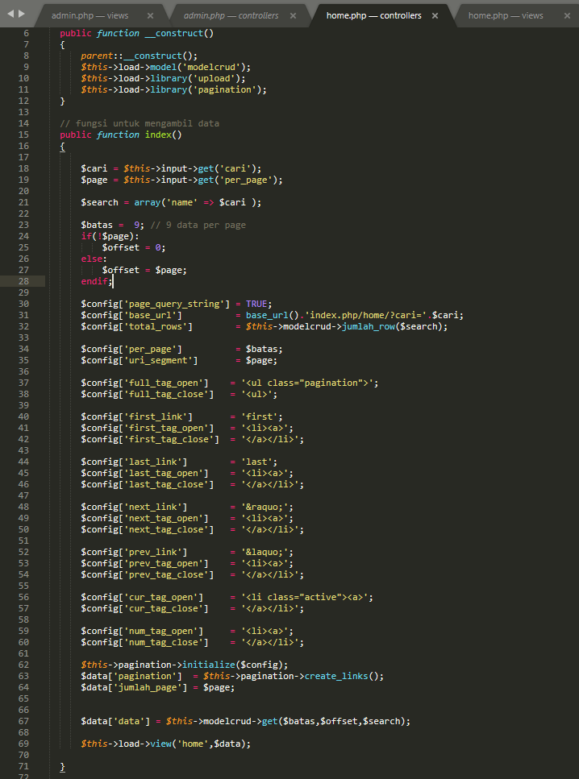

Gambar 1.1 Controller Home

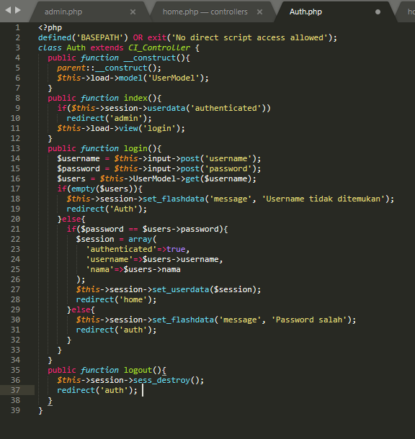

Gambar 1.2 Controller Login

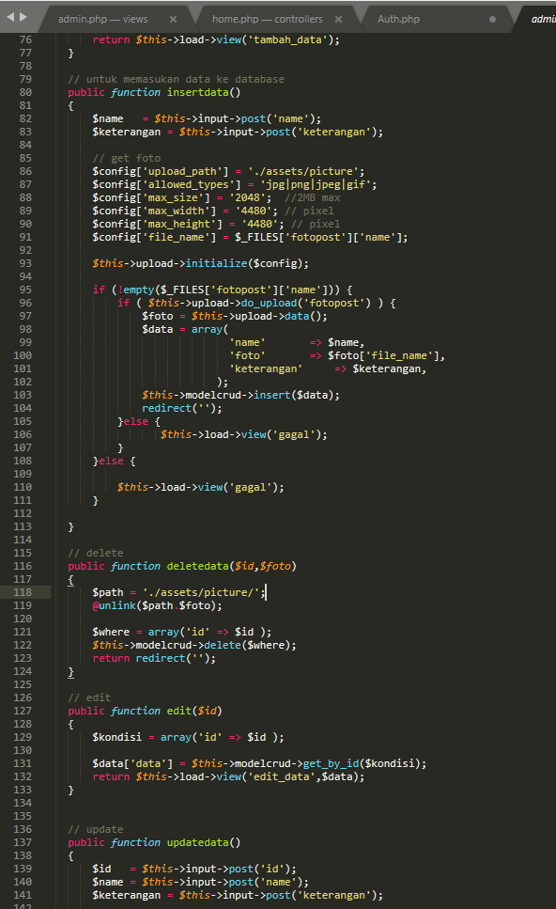

Gambar 1.3 Controller Admin

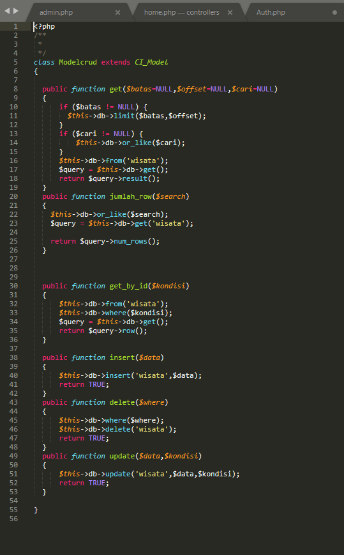

Gambar 2.1 Model CRUD

# 

# Gambar 3.1 View Home

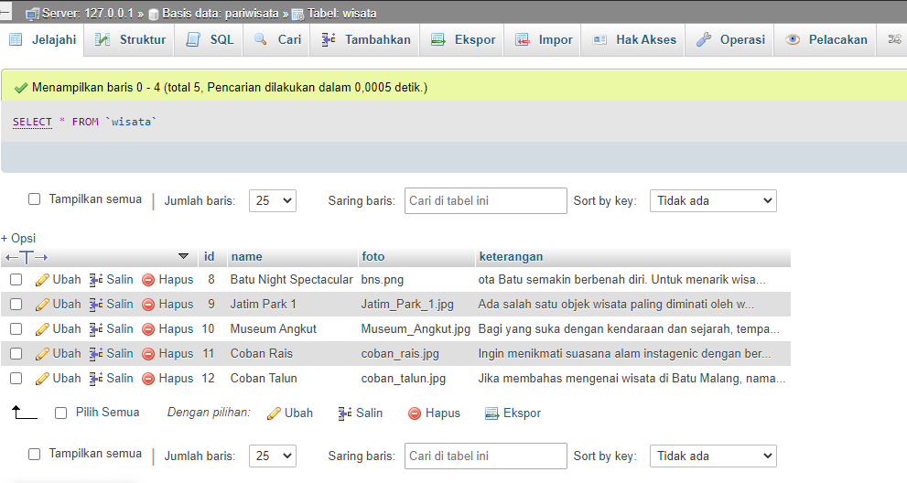

Gambar 4 SQL

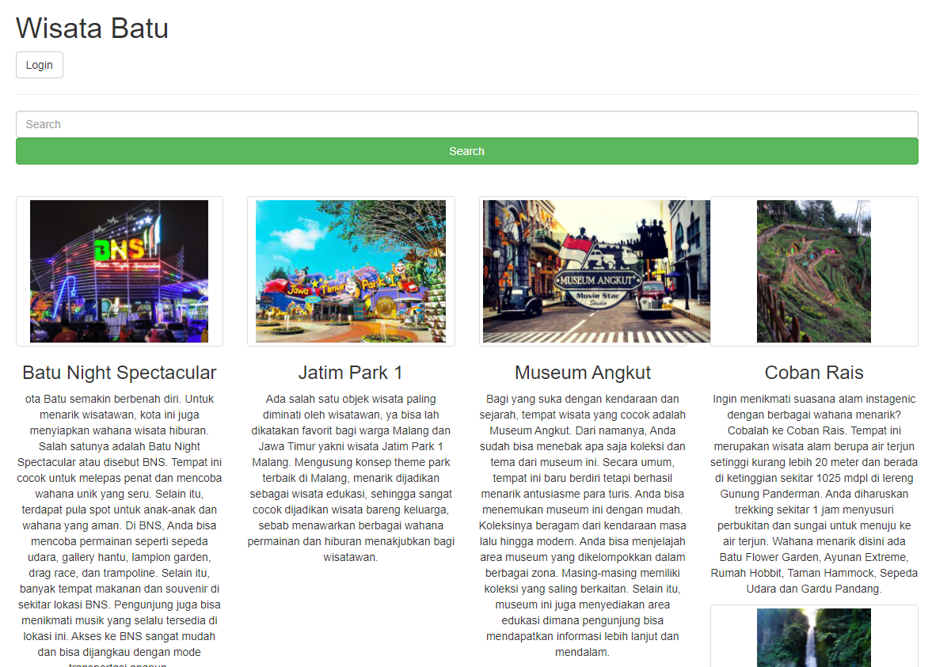

Gambar 5.1 Tampilan Awal

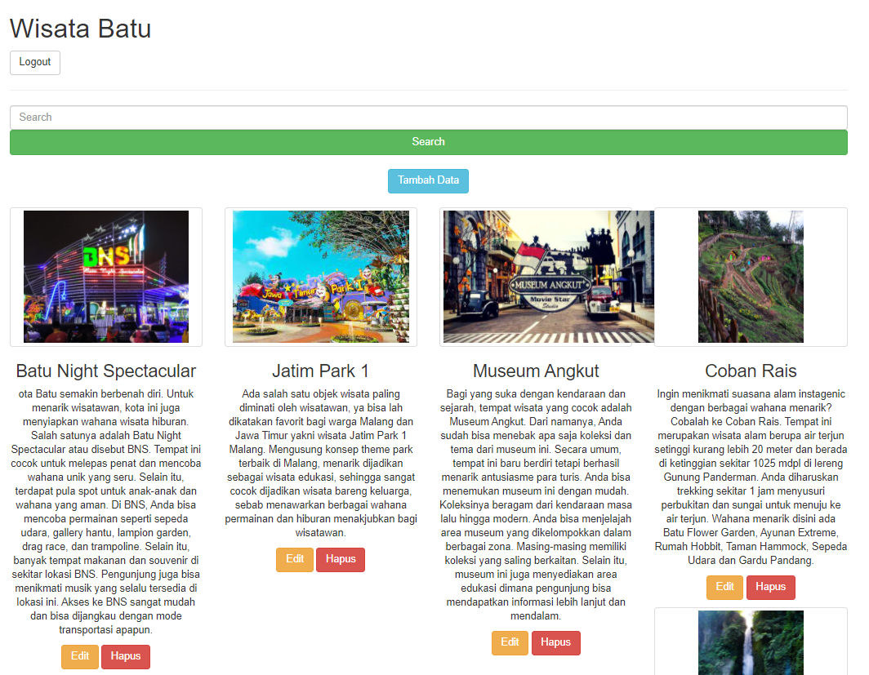

Gambar 5.2 tampilan admin